**Using the Alarm Detector Software**

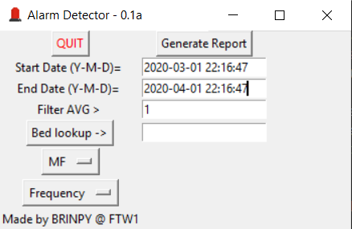

Upon opening the program, you have several options:

* ‘Start Date’ allows you to input any start date in the format “YYYY-MM-DD HH:MM:SS”
* ‘End Date’ allows you to input any end date in the format “YYYY-MM-DD HH:MM:SS”
* ‘Filter AVG >’ allows you to specify a minimum moving average to filter the equipment.
* ‘Bed lookup ->’ allows you to quickly view data from a specific bed.
* ‘MF’ is a dropdown that you can use to select ‘MF’ for motor faults, ‘J’ for jams, or ‘F’ for full.
* ‘Frequency’ is a dropdown that you can select whether to view and sort by alarm frequency or duration.
* ‘Generate Report’ generates a sorted list of equipment that match the criteria specified.

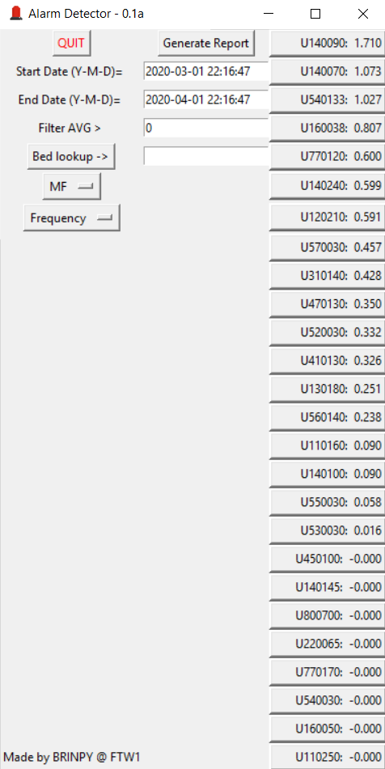

Upon generating the report you will be presented with a list of equipment that matches the criteria. The number simply represents the difference between a fast moving average and a slow moving average.

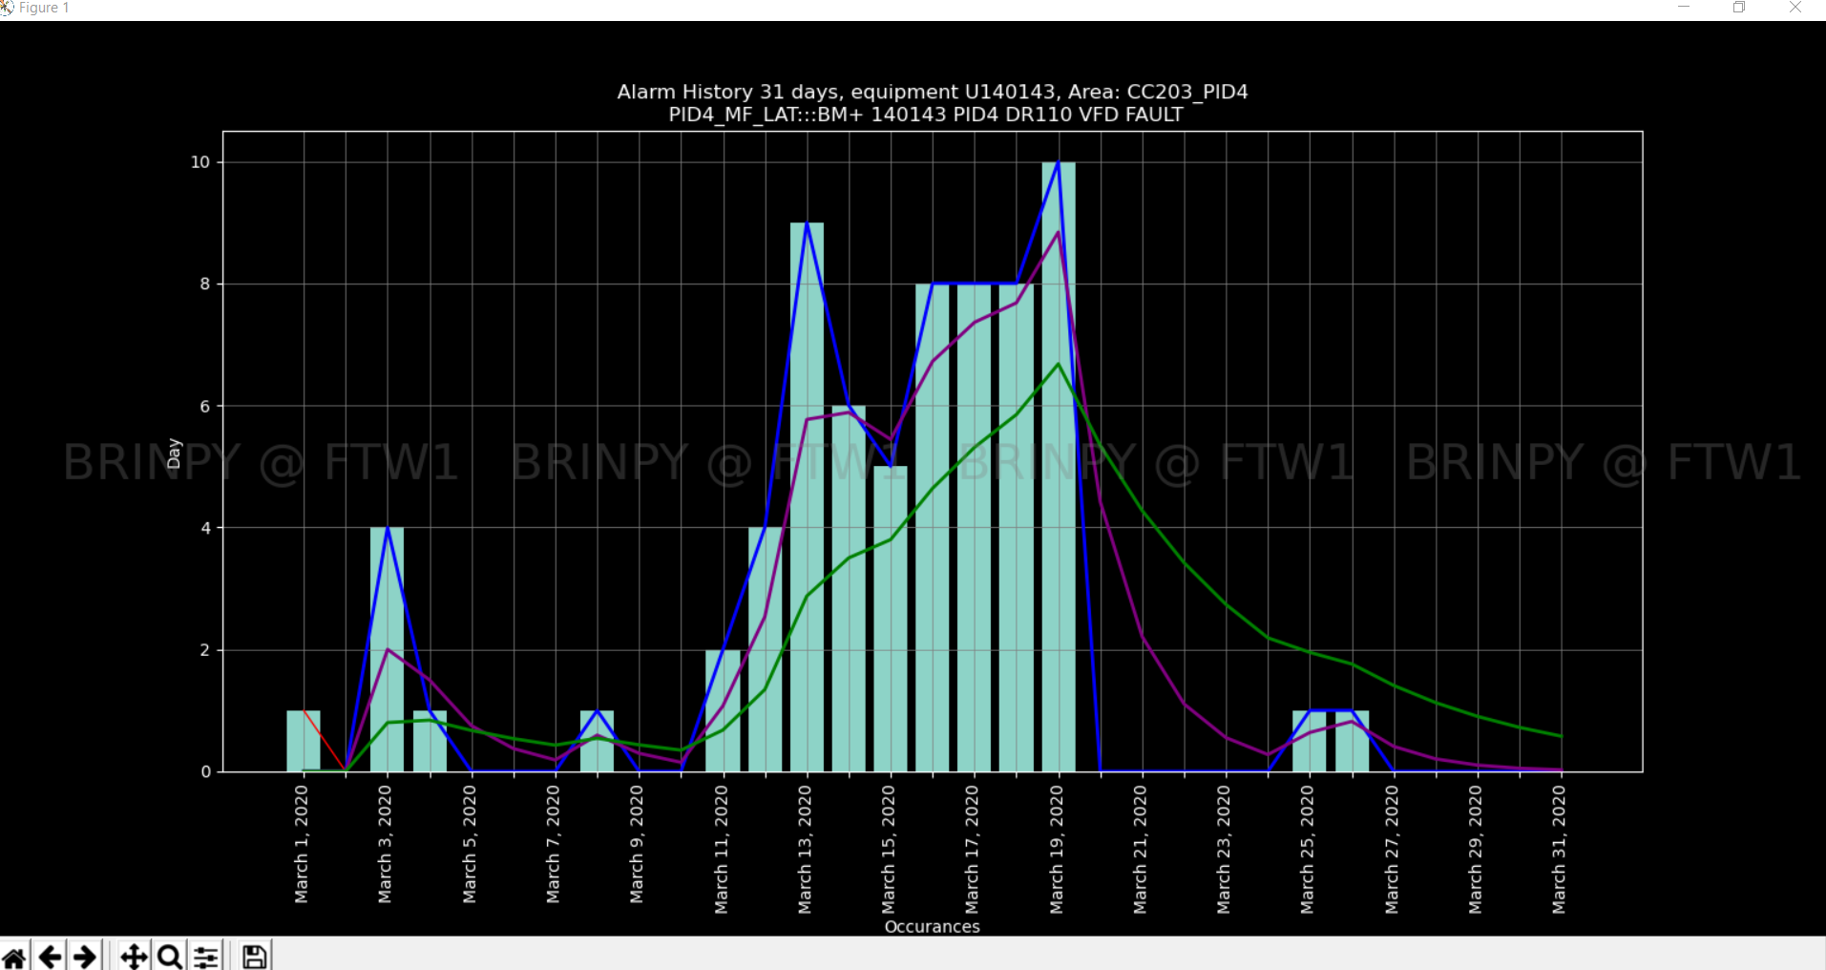

Upon selecting a bed number, you will be presented with a graph of the data that contains:

* A bar chart of the selected data for that bed over the selected time period.
* A green line that represents a slow exponential moving average (n=3)
* A purple line that represents a faster exponential moving average (n=1)
  + A note on the exponential moving averages:
    - Note: The numbers shown on the GUI next to the bed numbers is the difference between the fast and slow moving average. A positive number indicates an increase in the trend of alarms, and a negative number indicates a decrease. The number shown on the GUI is taken from the most recent day in the period (t=0).
    - Note 2: The filter AVG input filters noise from old alarms by comparing the value of the slower exponential moving average at t=0 to the filter value. If it is less than the filter value, the bed and data is not shown on the list of data.
* From this graph you can zoom in/out, pan the view, and save the figure as a PNG.

Notes:

* This software currently makes a connection to the alarms database in the facilities share drive. Thanks to the share drive’s performance, this results in *very* slow access rates for large queries. There is currently no planned fix for this.
* The database is only updated by one user laptop currently, so will be outdated when the user is out of the building.
* Report data discrepancies, bugs, and feature requests to Brinpy.